Field Creation and Data Type Configuration

Description :

The objective of this milestone is to create all required ﬁelds in the School IT Ticket table with correct data types, choices, and dependencies, ensuring structured and consistent data capture.

Step:1

Field Label:Number Type:Auto Number Reference/Choice:–

Step:2

Field Label:Caller Type:Reference
Reference/Choice:sys_user

Step:3

Field Label:Category Type: Choice
Reference/Choice:Network,Hardware,Access, Performance

Step:4

Field Label:Subcategory Type: Choice
Reference/Choice:[Wi-Fi,Projector,Forgot Password,Slow Compter]

Step:5

Field Label:Short Description Type:String

Reference/Choice:–

Step:6
Field Label: Description
Type: String

Reference/Choice:–

Step:7

Field Label:State Type: Choice
Reference/Choice:[New,In progress,On hold,Resolved,Closed]

Step:8

Field Label:Assigned Group Type: Reference
Reference/Choice:sys_user_group

Step:9

Field Label: Assigned to
Type: Reference
Reference/Choice:sys_user

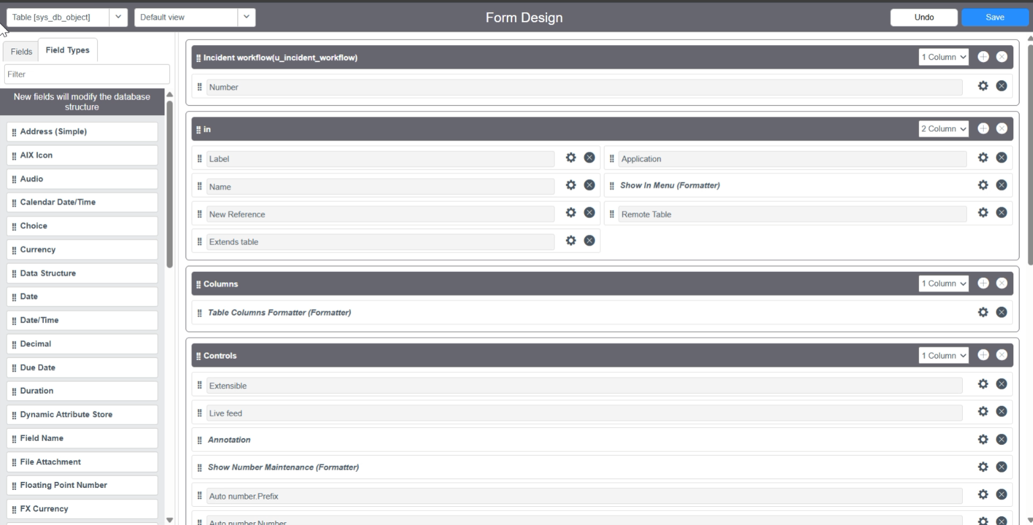

*After Creating Fields with their appropriate Type, then add the Choice from the Form design.
*To all the Choice list Fields.
*They are Category,Subcategory and State.
